**Deploy .Net Core on Azure Linux Server**

**Steps: -**

**1-we create Azure VM on ubuntu O.S with specify the subscription and resource group**

**2-we install the tools WinSCP and PUTTY on my Desktop were**

**PUTTY: are used to apply command such as update packages and install .net core 3.1, login, install NGNIX ,etc.….**

**WinSCP: are used to deliver files into the Azure VM target location on /home/m93enbah**

**2-we ensure that the network inbound role is access to port 80 as below**

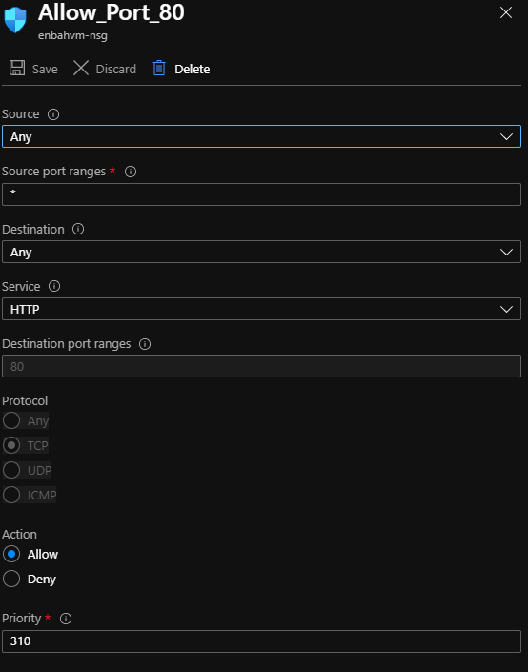

**3-on PUTTY we login to the Azure VM and apply the following commands**

**//to install the latest packages of Microsoft prod environment**

**wget https://packages.microsoft.com/config/ubuntu/18.04/packages-microsoft-prod.deb -O packages-microsoft-prod.deb**

**//to apply update these packages**

**sudo dpkg -i packages-microsoft-prod.deb**

**//to install HTTP packages and install .net core 3.1 SDK and update these pacakges**

**sudo apt-get update; \**

**sudo apt-get install -y apt-transport-https && \**

**sudo apt-get update && \**

**sudo apt-get install -y dotnet-sdk-3.1**

**//it will make http request to the localhost:5000**

**curl http://localhost:5000**

**//to install NGNIX on the Azure VM**

**sudo apt-get install nginx**

**//to stop NGNIX on the Azure VM**

**sudo service nginx stop**

**5-on WinSCP go to the path /etc/nginx/sites-available folder**

**Change the permissions for the default file using the following command on PUTTY**

**sudo chmod 777 default**

**6-with WinSCP go to the default file and change the content of the section location**

**location / {**

**# First attempt to serve request as file, then**

**# as directory, then fall back to displaying a 404.**

**proxy_pass http://localhost:5000;**

**proxy_http_version 1.1;**

**proxy_set_header Upgrade $http_upgrade;**

**proxy_set_header Connection keep-alive;**

**proxy_set_header Host $host;**

**proxy_cache_bypass $http_upgrade; }**

**7-on PUTTY start NGNIX server by execute the following command**

**sudo service nginx start**

**8-on Azure VM > DNS we make it static and make DNS name as below**

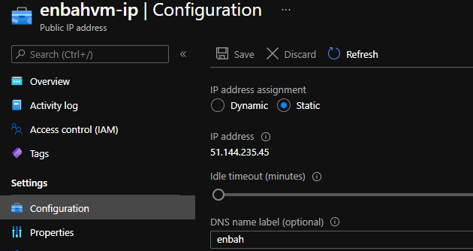

**9-make sure that run the SampleWebApp.dll on the PUTTY screen as below**

**Dotnet SampleWebApp.dll**

**10-on the browser type the below link as below**

**http://enbah.westeurope.cloudapp.azure.com/**